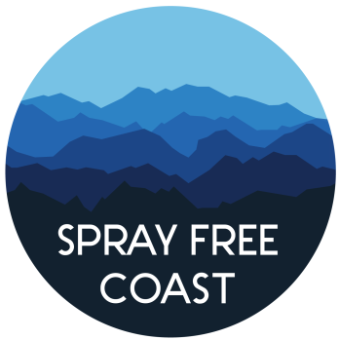

TIME FRAME when spray may occur: (list dates from the NOAP …)
COMMENTS DUE to ODF: [DATE] submit on FERNS or to ODF.
SITE NAME AND SIZE: (NAME OF OPERATION)
(ACRES)
WATERSHED: (watershed where this will take place)

CHEMICALS TO BE SPRAYED INCLUDE: REPLACE THIS TEXT WITH THE LIST OF CHEMICALS ON THE NOAP, FOUND UNDER THE INFORMATION IN THE “PRINT FULL REPORT” DOCUMENT …; additives: REPLACE THIS WITH ANY ADDITIVES LISTED, OR DELETE “carrier” IF NOT APPLICABLE FOR YOUR NOAP; carrier: REPLACE THIS WITH ANY ADDITIVES LISTED
CHEMICAL OPERATOR TO CONTACT: REPLACE THIS TEXT WITH OPERATOR NAME AND PHONE NUMBER
LANDOWNER TO CONTACT: REPLACE THIS TEXT WITH LANDOWNER NAME AND PHONE NUMBER
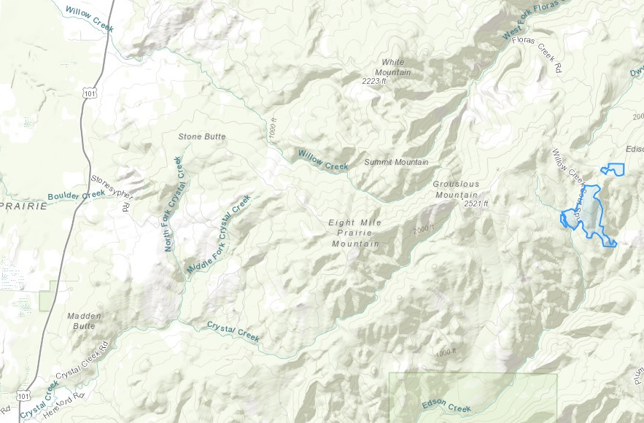
Herbicides applied to timber lands contain toxic chemicals that can negatively affect humans, wildlife, and ecosystem health – both on the land where they are applied and on the areas surrounding by drifting on air and fog, persisting in groundwater, and transferring through water sources.
FOR MORE INFORMATION VISIT sprayfreecoast.org
or contact (your organization name) at (PUT YOUR CONTACT INFORMATION HERE).
Contact the Oregon Department of Forestry at 541-267-4136 or [forester’s email here]
Notification NOAP: [replace with NOAP], Source: https://ferns.odf.oregon.gov/e-notification

